SwiftShip Tracker
Parcel Management Portal on Salesforce CRM
Phase 1: Requirement Analysis & Planning

Use Case Overview
Customers often face delays and confusion while booking, tracking, and managing parcel deliveries because they need to call support or use multiple apps. A conversational AI agent can simplify this by allowing customers to book parcels, get live tracking, and manage deliveries in one place.
Objective: build a Parcel Management Portal on Salesforce CRM where customers book parcels, track delivery status, and manage shipments through a user-friendly interface, while agents update parcel details, delivery timelines, and status to keep customers informed.

Key Features
- Parcel booking and record creation
- Parcel status tracking (Booked, In Transit, Out for Delivery, Delivered)
- Weight and delivery date management
- Automated customer notifications for delivery updates
- Agent interface to manage and update parcel details

Story 1: Defining Project Scope & Objectives

Project Scope
- Build a scalable CRM solution for parcel delivery businesses to manage customer bookings, shipments, and delivery operations.
- Support the end-to-end parcel lifecycle: booking, dispatch, tracking, and delivery confirmation.
- Include data model design, automation (Flows, Apex, Email Alerts), an AI-powered Prompt Builder, and reporting dashboards.
- Provide role-based access for admins, delivery agents, and customers through profiles, permission sets, and Experience Cloud.
- Provide real-time parcel visibility for customers and simple operational tracking for agents through AI-integrated conversational support.

Out of Scope
- Online payment gateway integration
- GPS or IoT hardware tracking
- Native mobile application
- Multi-currency pricing and invoicing

Objectives Summary
- Streamline operations: Automate booking, tracking, and delivery notifications to reduce manual updates.
- Improve customer satisfaction: Give transparent, real-time shipment status and self-service tracking.
- Enhance agent efficiency: Provide centralized dashboards and guided Flows for quick status updates.
- Enable business insights: Provide reports and dashboards on parcel trends, delivery performance, and agent activity.
- Ensure security and reliability: Implement role hierarchies, sharing rules, and audit-based data access.

Success Metrics
Metric | Target
Status changes that trigger a customer email | 100%
Parcel lookup by Parcel ID | Under 5 seconds
Manual status update steps for an agent | One Screen Flow, under 3 clicks
Dashboard visibility | Delivered vs. pending parcels, per agent

Story 2: Gathering & Analysing User Needs

Users Involved
User | Role in the system | Access channel
Customer / Sender | Books parcels, tracks deliveries, receives real-time updates | Experience Cloud portal, AI agent
Delivery Agent | Manages assigned parcels, updates delivery status, hands over to customers | Lightning App (SwiftShip Tracker)
Customer Support Team | Handles delivery issues and customer queries | Case + Parcel records
Admin Team | Configures the org, manages roles and security, monitors performance | Setup, Reports, Dashboards
System Integrator / Developer | Implements automation, AI agent setup, and backend integrations | Flow Builder, Apex, Prompt Builder

Key Functional Needs
- Parcel booking and tracking interface for customers through an Experience Site or agent assistance.
- Agents update parcel status (Booked, In Transit, Out for Delivery, Delivered) in real time.
- Automated notifications and email alerts to customers at every delivery stage.
- Sender and Receiver management with address, contact, and email fields.
- AI agent (Prompt Builder) for real-time parcel status queries and automated assistance.
- Reports and dashboards for parcel flow, delivery performance, and agent activity.
- Role-based security with profiles and permission sets.

User Stories
ID | User story | Solution
US-01 | As a customer, I want to book a parcel online so that I do not need to call support. | Experience Cloud + Screen Flow
US-02 | As a customer, I want to enter my Parcel ID so that I can see my current delivery status. | Prompt Builder / Agentforce
US-03 | As a delivery agent, I want to update a parcel's status in one screen so that customers are informed quickly. | Screen Flow + Record Page
US-04 | As a sender, I want an email at every status change so that I know where my parcel is. | Record-Triggered Flow + Email Alert
US-05 | As a support agent, I want to see the parcel history on a Case so that I can resolve issues faster. | Case + Related List
US-06 | As an admin, I want dashboards of delivered vs. pending parcels so that I can monitor performance. | Reports and Dashboards

Tools Used
- Salesforce Developer Org for configuration, development, and testing
- Prompt Builder (Agentforce AI) for parcel tracking prompts and responses
- Salesforce Flow Builder for booking, tracking, and delivery update automation
- Google Sheets / Docs for data planning, requirement documentation, and system mapping

Story 3: Identifying Key Salesforce Features & Tools Required
Category | Planned features
Custom Objects | Parcel__c, Delivery__c, Sender__c, Receiver__c
Standard Objects | Account, Contact, Case, Task, EmailMessage, User
Automation | Record-Triggered Flows (status change emails), Screen Flows (booking, agent status update), Auto-Launched Flows, Scheduled Flows (delayed-parcel reminders)
Apex | Apex classes for parcel operations such as delivery notifications and status updates; Batch Apex for periodic notifications or updates
Approval Process | Approval for parcel cancellation or return requests
User Interface | Lightning App (SwiftShip Tracker), Lightning Record Pages, Dynamic Forms for Parcel details, Experience Cloud for customers
Agentforce & Prompt Builder | AI agent that fetches parcel data by Parcel ID and answers tracking and delivery status queries
Email Services | Email Templates and Alerts for booking confirmation, delivery updates, and completion acknowledgment
Security | Profiles, Permission Sets, Role Hierarchy, Field-Level Security, Sharing Rules
Reporting | Reports and Dashboards: parcels by status, delivery performance, agent activity

Story 4: Designing Data Model & Security Model

Data Model
Parcel__c is the central object. Sender__c and Receiver__c are linked to it by Lookup relationships, and each Parcel has many Delivery__c tracking records.
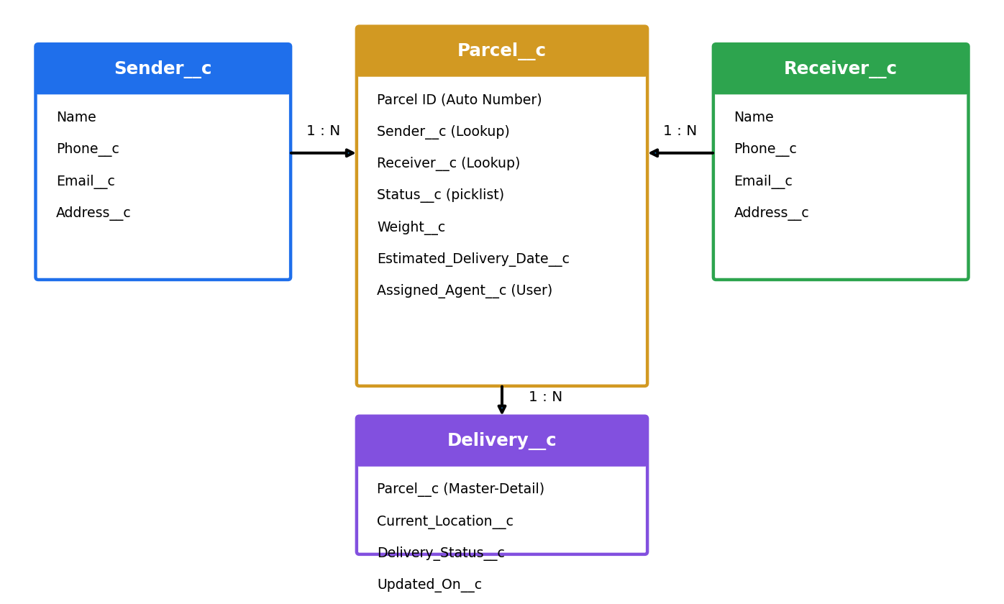
Figure 1: Entity Relationship Diagram

Parcel__c
Stores core parcel details and links both ends of the shipment.
Field | Type | Purpose
Parcel ID | Auto Number (PRC-{0000}) | Unique tracking ID
Sender__c | Lookup(Sender__c) | Who sent the parcel
Receiver__c | Lookup(Receiver__c) | Who receives the parcel
Status__c | Picklist | Booked, In Transit, Out for Delivery, Delivered
Weight__c | Number | Parcel weight in kg
Estimated_Delivery_Date__c | Date | Expected delivery date
Assigned_Agent__c | Lookup(User) | Delivery agent responsible

Delivery__c
Each record is one tracking update for a parcel, used by agents during the lifecycle.
Field | Type | Purpose
Parcel__c | Master-Detail(Parcel__c) | Parent parcel
Current_Location__c | Text | Latest known location
Delivery_Status__c | Picklist | Status at this update
Updated_On__c | Date/Time | When the update was logged
Delivered_On__c | Date/Time | Actual delivery time

Sender__c
Captures sender details and history; used for booking confirmations and delivery emails.
Field | Type | Purpose
Name | Text | Sender name
Phone__c | Phone | Contact number
Email__c | Email | Notification email
Address__c | Text Area | Pickup address

Receiver__c
Stores receiver details for delivery reference and completion emails.
Field | Type | Purpose
Name | Text | Receiver name
Phone__c | Phone | Contact number
Email__c | Email | Notification email
Address__c | Text Area | Delivery address

Relationships
- One Sender has many Parcels (Lookup).
- One Receiver has many Parcels (Lookup).
- One Parcel has many Delivery records (Master-Detail). Delivery links to Parcel only, so sender and receiver data is not duplicated.

Security Model
Role hierarchy (internal users): Administrator → Delivery Manager → Agent. Customers are external Experience Cloud users and are not part of the internal hierarchy; their access comes from sharing sets.
Object | Admin | Delivery Manager | Agent | Support | Customer
Parcel__c | CRUD | CRUD | Read, Edit | Read | Read (own)
Delivery__c | CRUD | CRUD | Read, Edit | Read | Read (own)
Sender__c / Receiver__c | CRUD | CRUD | Read, Edit | Read | Read (own)
Case | CRUD | Read | Read | CRUD | Create, Read (own)

- Admin Profile: Full access to all objects and records.
- Delivery Agent Profile: Read/Edit on Parcel, Delivery, Sender, and Receiver.
- Customer Profile: Read-only access to their own parcels via Experience Cloud.
- Support Staff Profile: Access to Cases and Parcel details for issue resolution.
- Permission Sets: Additional privileges such as Update Delivery Status and Access Agent Console.
- Record-Level Security: Sharing Rules on Parcel__c and Delivery__c for agents and managers; customers see only records linked to their own Sender or Receiver details.
- Field-Level Security: Sender Email, Receiver Contact, and Location fields restricted to Admin and Agent profiles.

